Setup New Computer

# Software:

* Virtual CloneDrive (Freeware) - <http://www.slysoft.com/en/download.html>
* NotePad++ - [http://notepad-plus-plus.org](http://notepad-plus-plus.org/download/v6.5.3.html)
* Set Up Git – download github for windows - <https://help.github.com/articles/set-up-git>
* Fiddler - <http://www.telerik.com/download/fiddler>
* Google Chrome
  + Theme - Morpheon Dark
  + Extension - Turn Off the Lights or Late Night
  + Web Developer:  
    https://chrome.google.com/webstore/category/apps?hl=en-US   
    http://chrispederick.com/work/web-developer/installed/chrome/04/
* ObjectDock - <http://www.stardock.com/products/objectdock/>
* Paint.Net - <http://www.getpaint.net/>
* Remote Desktop Connection Manager - <http://www.microsoft.com/en-us/download/details.aspx?id=21101>   
  Copy rdg file (C:\Program Files (x86)\Remote Desktop Connection Manager) from old machine to new.
* Launchy - <http://www.launchy.net/>
* Poor Man's T-SQL Formatter - <http://www.architectshack.com/PoorMansTSqlFormatter.ashx>
* Garmin Communicator Plugin - <http://software.garmin.com/en-US/gcp.html>
* SoapUI

# Fix Annoying Stuff:

* Windows Explorer – uncheck ‘hide extensions for known file types’  
  Control Panel\All Control Panel Items\Folder Options --> View
* Windows Snipping Tool:
  + Properties – Shortcut – Shortcut key: - Ctrl + Alt + P
  + Snipping Tool Options – uncheck ‘Prompt to save snips before exiting’
* Visual Studio:
  + Tools > Options > General > Color Theme: Dark
  + Items shown in window menu – 24
  + Items shown in recently used lists – 24
* Outlook 2010:
  + File > Options > General > Color scheme: Black
* Office 2013:
  + File > Account > Office Theme: Dark Gray
* Internet Explorer:  
  Tools > Manage Add-ons > Search Providers > Find more search providers > Google, Stackoverflow, msdn
* Remove Windows 7 Taskbar Labels
  + Run regedit
  + Go to HKEY_CURRENT_USER -> Control Panel -> Desktop -> WindowMetrics
  + Find entry "MinWidth" if it doesn’t exist create it, right click on an empty space and select New -> String Value. Name this entry "MinWidth" (without quotes)
  + Double click on the MinWidth entry. If you want just the buttons to show, set this to 38 if you're using small buttons, 52 if you're using large buttons (or 54 in Windows 8). Otherwise any value above 38 will work. If you set a value below 38, the buttons will behave oddly.
  + Log off and log back in or restart to see the changes.
* Outlook 2013:
  + Always open the full Contact editing form from People Search  
    <http://www.howtogeek.com/173144/how-to-open-the-full-contact-editing-window-in-outlook-2013/>   
    To always open the full Contact editing form when clicking on a search result from the People Search, you can apply the following Registry fix.  
    Key: HKEY_CURRENT_USER\Software\Microsoft\Office\15.0\Common\Contactcard  
    Value name: turnonlegacygaldialog  
    Value type: REG_DWORD  
    Value: 1  
    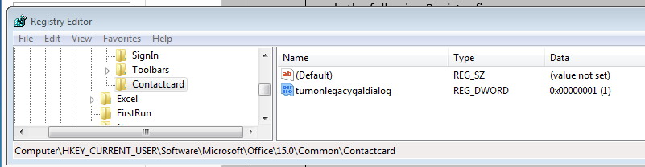
  + Disable SkyDrive in Office 2013  
    The dword to add with a zero value is below HKEY_CURRENT_USER\Software\Microsoft\Office\15.0\Common\Internet\useOnlineContent   
    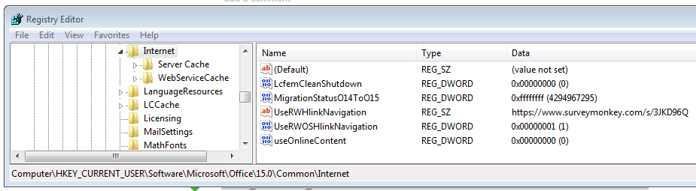

# Chrome Bookmarks:

* <http://pluralsight.com/training>
* dmpl.org
* [www.worldscienceu.com](http://www.worldscienceu.com)
* dictionary.reference.com
* <https://www.linkedin.com>
* iadnug.org
* <https://github.com>
* msdn.microsoft.com/en-us/subscriptions
* <https://groups.google.com/forum/#!myforums>
* <https://mail.google.com/mail/#inbox>
* [https://www.google.com/calendar](https://www.google.com/calendar/render?tab=mc)
* <https://twitter.com>
* <https://onedrive.live.com>
* plnkr.co
* [www.microsoftvirtualacademy.com/ebooks](http://www.microsoftvirtualacademy.com/ebooks)
* <https://duckduckgo.com>
* america.aljazeera.com
* [www.runningintheusa.com/Race/List.aspx?State=IA](http://www.runningintheusa.com/Race/List.aspx?State=IA)
* connect.garmin.com/dashboard
* <https://www.apress.com>